Instructions for Students Taking a HEIghten® Assessment on Territorium

Please read through this entire document before beginning the assessment.

BEFORE YOU START
- It will take about 45 minutes to an hour to finish your assessment. Ensure that you can allocate enough time to work without interruptions. Once you start, you must finish it.
- Use Chrome browser. Make sure it is installed on your computer before you start.
- If you need a calculator, you must use the one provided with the test on your screen.
- If you get unexpectedly disconnected, log back in (see below).
- E-mail support@territorium.com for technical support.

Getting Started
- You should have received a code from your professor to take the test.
- Go to https://life.territorium.com
- Click on “Enter code.”
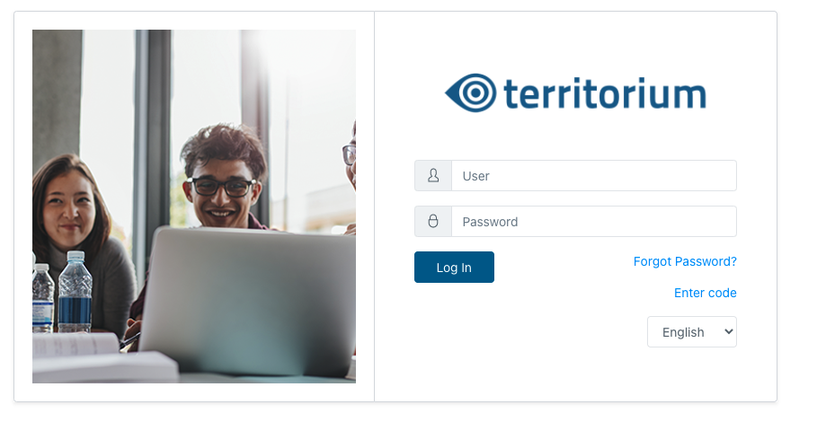
- Type the code. If you already have an account with Territorium, click “Login”; otherwise, create a new account by clicking “Create an account.”
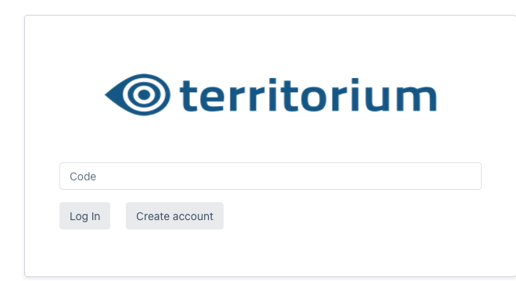
- Fill in all the required fields. Once you finish, you’ll be automatically redirected to your homepage.
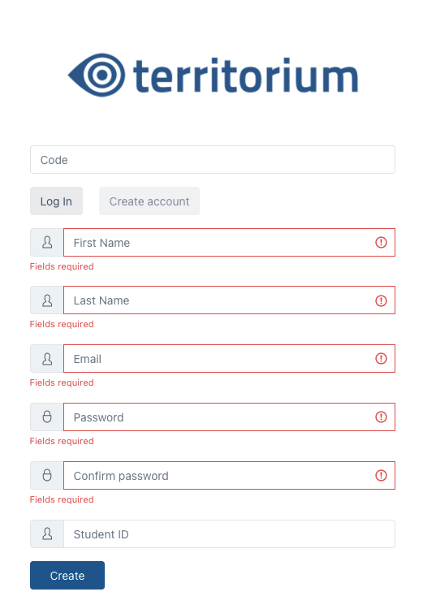
- You’ll see the tests you have assigned. You can also see if a test is open or closed , as well as the start and end dates. When you are ready, click on the test.
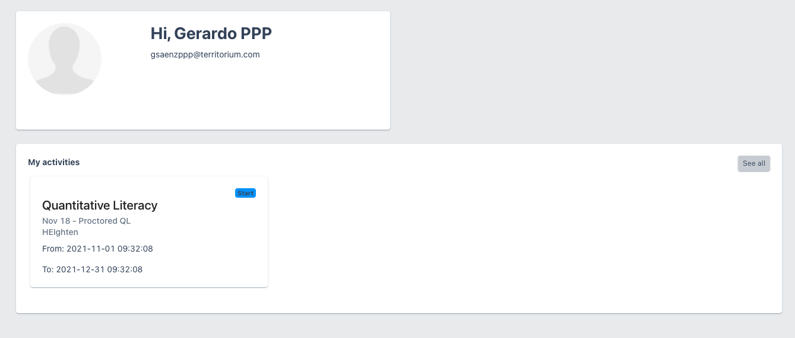

Taking the test
- Once you start, review the instructions that appear on the following page. Instructions may change depending on the test you’re taking. When ready, click “Start.”
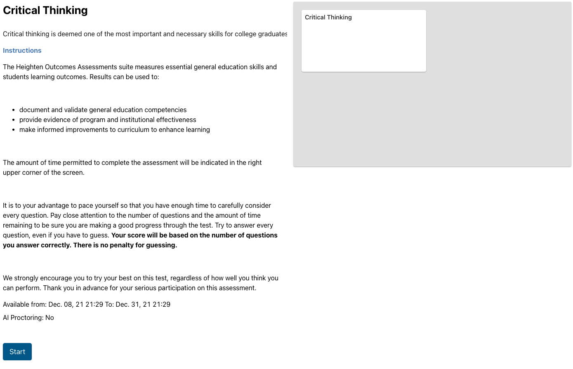

- Choose your answer and navigate through the test using the “Previous” and “Next” buttons.

- You can also move through the questions by clicking on a specific question number.

- If you need to highlight a question to return later to it, you can click the “Highlight” button. You’ll see the question number marked in yellow.

- You’ll see how much time is left on the top right corner.
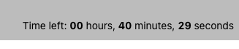
- Review the number of questions answered once you’re finished and click “Submit and Continue.”
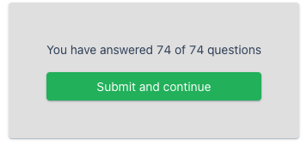
- You’ll be returned to the test’s welcome page. The status “Completed” will appear, and also, if available, the “Score Report.”
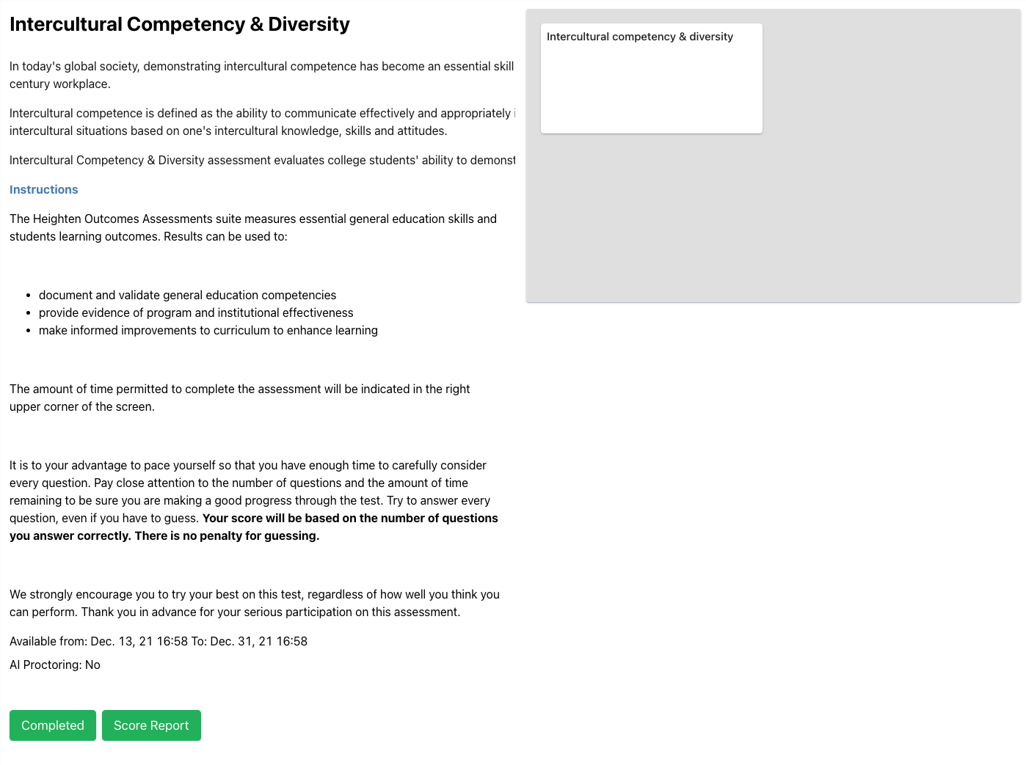
- You’re done! Congratulations!

